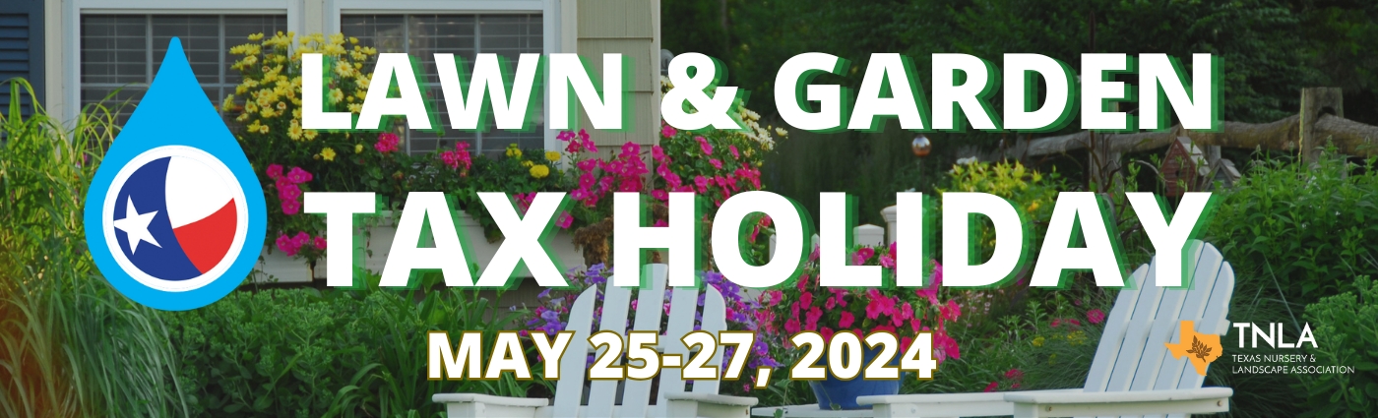
Name of Retail Garden Center |  | Participating Location(s) |  | Phone Number | Web address to be linked to your company:
Fannin Tree Farm |  | 15700 State Highway 121 Frisco, TX 75035 |  | 972.747.9233 | www.fannintreefarm.com
Wabash Feed and Garden |  | 4537 North Shepherd Dr. Houston, TX 77018 |  | 713- 863-8322 | www.wabashfeed.com
Turner's Gardenland |  | 6503 S Padre Island Drive, Corpus Christi, TX 78412 |  | 361-991-9002 | https://turnersgardenland.com |  |  |  |  | https://turnersgardenland.com/
Fairway Landscape & Nursery, Inc. | 12802 Robert Glenn |  |  |  |  | www.salandscape.com
Smith's Gardentown | 4940 Seymour HIghway, Wichita Falls, TX 76310 |  |  | 940-692-7100 | www.smithsgardentown.com
Kims home and garden |  |  | 2715 Lake Rd., Huntsville, TX |  | Kimshomeandgardencenter.com
Enchanted Gardens | 6420 FM 359 Road, Richmond, Texas 77406 | 281-341-1206 | www.enchantedgardensrichmond.com
HILL COUNTRY AFRICAN VIOLETS & NURSERY | 32005 I. H. 10 WEST, BOERNE, TEXAS 78006 | 830-249-2614 | HCAVandnursery.com
Padre Palms and Landscape | 10015 S Padre Island Dr, Corpus Christi, Tx, 78418 | 361-937-7700 | www.padrepalms.com
Marshall Grain Co. | 5311 Colleyville BLVD COLLEYVILLE TX 76034 | 817-416-6600 | www.marshallgrain.com
Buchanan’s Native Plants | 611 East 11th Street Houston, TX 77008 | 713-861-5702 | Buchanansplants.com
The Home & Garden Center | 4513 West Loop 281, Longview TX 75604 | 903-753-2223 | www.thgc.net
The Garden Center | 10682 Bandera Rd San Antonio, TX 78250 | 210-647-7900 | www.thegardencenter.com
Warren's Southern Gardens | 1675 Northpark Drive, Kingwood, TX 77339 | (281) 354-6111 |  | www.warrens.us
Gray’s Nursery & Garden Center | 5685 S SH 37  Mineola, TX 75773 |  | (903) 569-9029
Pecan Ace Garden Center | 2840 Village Rd., Granbury, TX 76049 |  | (248) 250-2057 | www.pecanace.com
Fanick's Garden Center | 1025 Holmgreen Rd, San Antonio, TX 78220 |  | 210-648-1303 | www.Fanicknursery.com
Rainbow Gardens | 8516 Bandera Rd, San Antonio, TX 78250 |  | (210) 680-2394 | www.rainbowgardens.biz
Rainbow Gardens | 2585 Thousand Oaks Dr, San Antonio, TX 78232 |  | (210) 494-6131 | www.rainbowgardens.biz
LAWNS Tree Farm | 400 Honeycomb Mesa Leander TX 78641 |  | (512) 450-3336 | www.Lawnstrees.com
SANTOS NURSERY | 1202 NEW LAREDO HWY SAN ANTONIO TX 78211 |  | (210) 924-3373

