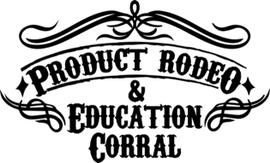

Location & Directions:
For the most direct route to the correct part of the Will Rogers Memorial Center, enter this address in your GPS: 1501 Rip Johnson Dr, Fort Worth, TX 76107.

Enter from Trail Drive to park in the Equestrian Center garage (#3 on this map). Parking is $10 per day and a one or two day pass can be purchased at the gate.

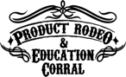
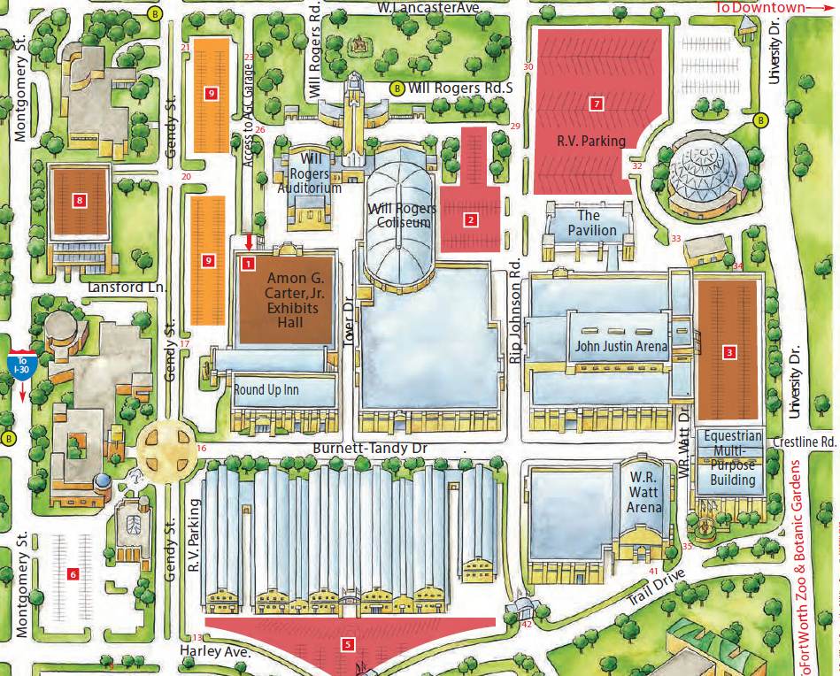

Badge Pick Up:
If you’re checking in Wednesday morning for the Education Corral or the Keynote lunch, head to the registration tables in the John Justin Arena. Product Rodeo check in Wednesday afternoon and all day Thursday is located in the Watt Arena. Just follow the signs from the parking lot!

On site registration is available for anyone in your group who has not pre-registered.

Food:
Will Rogers concessions will be open during the event, to handle all your food and beverage needs.

Attire:
Dress is casual and boots are recommended! Attendees will be able to ride equipment and use machinery in the demo area. Be sure to wear something you feel comfortable operating in.

After the show:
Fort Worth offers a wide variety of restaurants, attractions, and night life for your and your crew after the Rodeo. Consider visiting the popular 7th street district, just north of the arena. Several local businesses even offer a discount if you show your badge from the event when you visit.

